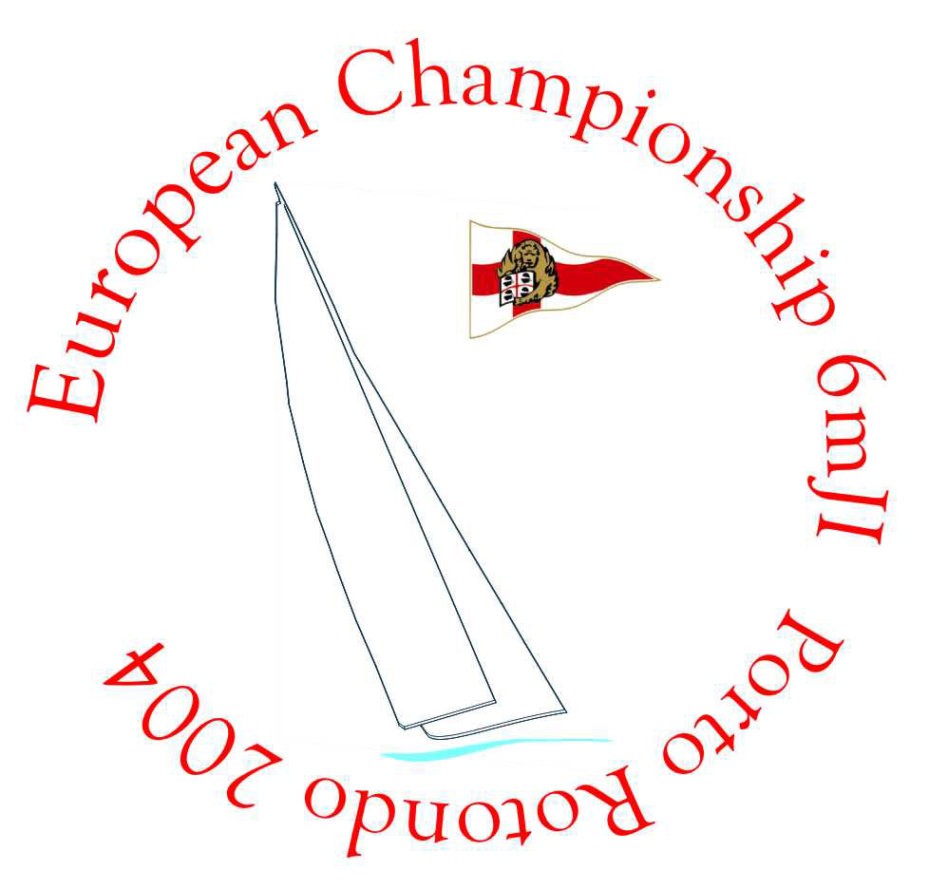

PORTO ROTONDO
13th – 17th SEPTEMBER 2004

FINAL RESULTS WITH 1 DISCARD
After Race 7 and Race 8

CLASSIC

SAIL NR. | BOAT NAME | SKIPPER | RACE 1 | RACE 2 | RACE 3 | RACE 4 | RACE 5 | RACE 6 | Race 7 | RACE 8 | SCORE
US 60 | NANCY | POM GREEN | 1 | 1 | 1 | 1 | 1 | 1 | 2 | 4 | 8
FRA 111 | DIX AOUT | PIERRE PAUL HECKLY | 3 | 2 | 3 | DNS | 5 | 5 | 1 | 1 | 20
D 43 | DAN | MARINA CARPANEDA | 4 | 4 | 2 | 2 | 2 | 4 | 5 | 2 | 20
US 54 | BOBKAT II | DOUG PETERSON | 2 | 3 | DNF | DNS | 3 | 3 | 3 | 3 | 23
6 G 30 | MENA | THOMAS KUHMANN | 5 | 5 | 4 | 3 | 4 | 2 | 4 | 5 | 27

